
Elm Class Timetable Autumn 2025
Monday | Tuesday | Wednesday | Thursday | Friday
  English/Phonics | Swimming | English/Phonics | English | Assembly
 |  |  |  | Music
snack
playtime
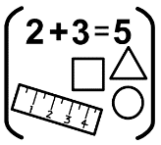  Maths | 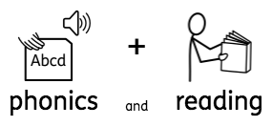  Reading/phonics | 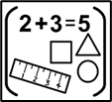  Maths | Maths | 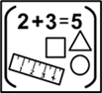  Maths
lunch
relax
  Science |   Art |   Humanities |   Life skills- PSHE |   ICP
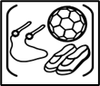

PE

 |   LIFE Skills- RE (Faith) | Zones of Regulation |   Computing

