Join us for our
Nativity and Christmas Fayre

On Tuesday 15th December we will be holding our Christmas Fayre in school.

All the children will be involved and classes will have activities based in their classrooms. There will be a Grotto with Father Christmas and his Elves based in the bungalow.
Please join us if you can ~
and bring any children who
may want to meet Santa!

Yellow Class will be hosting a Christmas-themed photo booth
Pink Class will be running a Café selling drinks and mince pies
Blue Class will run a Tombola stall
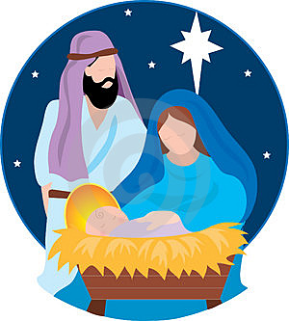
Purple Class will have a Sweet Jar stall similar to the one at our Sports Day, which proved very popular and there will be
Raffle Tickets on sale ~ which Orange Class will be helping to sell.

Green, Red and Orange Class children will be performing our Key Stage 1 Nativity Play during the afternoon as well. This will be mainly for KS1 parents to attend, but if there are any spare places then other parents will be able to watch.

